# GamesPlay App - Python Web Basics Retake Exam

*The app allows the user to browse different games, including the rating, category, highest experience level, and a summary. The user can create, edit, or delete games at any time. He/ She can also edit or delete his/ her profile.*

## Skeleton

You are provided with all the needed **HTML pages**, **images,** and **CSS** for the project.

## Database

You will need **2 models**:

* **Profile Model**
  + **Email**
    - Email field, **required**.
  + **Age**
    - Integer field, **required**.
    - The age cannot **be below 12**.
  + **Password**
    - Character (password) field, **required**.
    - It should consist of a **maximum** **of 30 characters.**
  + **First** **Name**
    - Character field, **optional**.
    - It should consist of a **maximum** **of 30 characters.**
  + **Last** **Name**
    - Character field, **optional**.
    - It should consist of a **maximum** **of 30 characters.**
  + **Profile** **Picture**
    - URL field, **optional**.
* **Game Model**
  + **Title**
    - Character field, **required**.
    - It should consist of a **maximum** **of 30 characters.**
    - All game **titles** **must** be **unique**.
  + **Category**
    - Character (choice) field, **required**.
    - It should consist of a **maximum** **of 15 characters.**
    - The choices are **"Action"**, **"Adventure"**, **"Puzzle"**, **"Strategy"**, **"Sports"**, **"Board/Card Game"**, and **"Other"**.
  + **Rating**
    - Float field, **required**.
    - The rating can be **between** **0.1 and 5.0** (**both** **inclusive**).
  + **Max Level**
    - Integer field, **optional**.
    - The max level **cannot** **be below 1**.
  + **Image URL**
    - URL field, **required**.
  + **Summary**
    - Text field, **optional**.

**Note: the validations will be examined only by the user side, not the admin side.**

## Routes

* <http://localhost:8000/> - home page
* <http://localhost:8000/>profile/create - create profile page
* <http://localhost:8000/>dashboard/ - dashboard page
* <http://localhost:8000/game>/create/ - create game page
* [http://localhost:8000/game/details/<id](http://localhost:8000/game/details/%3cid)>/ - details game page
* [http://localhost:8000/game/edit/<id](http://localhost:8000/game/edit/%3cid)>/ - edit game page
* [http://localhost:8000/game/delete/<id](http://localhost:8000/game/delete/%3cid)>/ - delete game page
* <http://localhost:8000/profile/details/> - details profile page
* <http://localhost:8000/profile/edit>/ - edit profile page
* <http://localhost:8000/profile/delete>/ - delete profile page

## Pages

### Home Page - 10p

**Template file**: **"home-page.html"**

The page consists of:

* A **navigation bar** with:
  + **"GamesPlay"** link, which leads to the **home** page.
  + **"Create Profile"** link, which leads to **create profile** page.
  + **"Dashboard"** link, which leads to the **dashboard** page.
  + **"Create Game"** link, which leads to the **create game** page.
  + **"Profile"** link, which leads to the **details** **profile** page.
* **"All new games are only in GamesPlay" headline** and a **default image**.

Keep in mind that the **"Create Profile"** link on the navigation bar is **only visible** when the user **has NOT created a profile yet**:

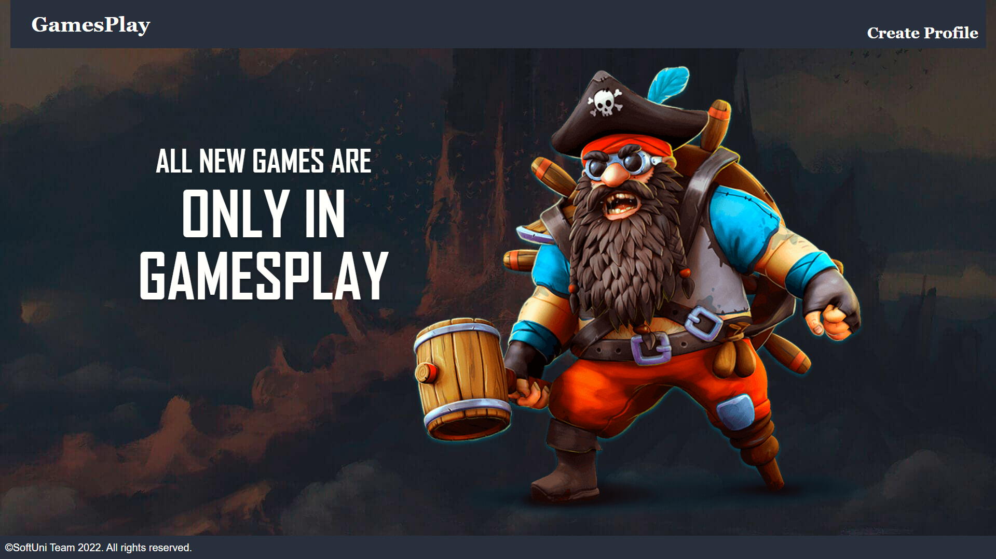

The **"Dashboard"**, **"Create Game"**, and **"Profile"** links on the navigation bar are **only visible** when the user **has a profile:**

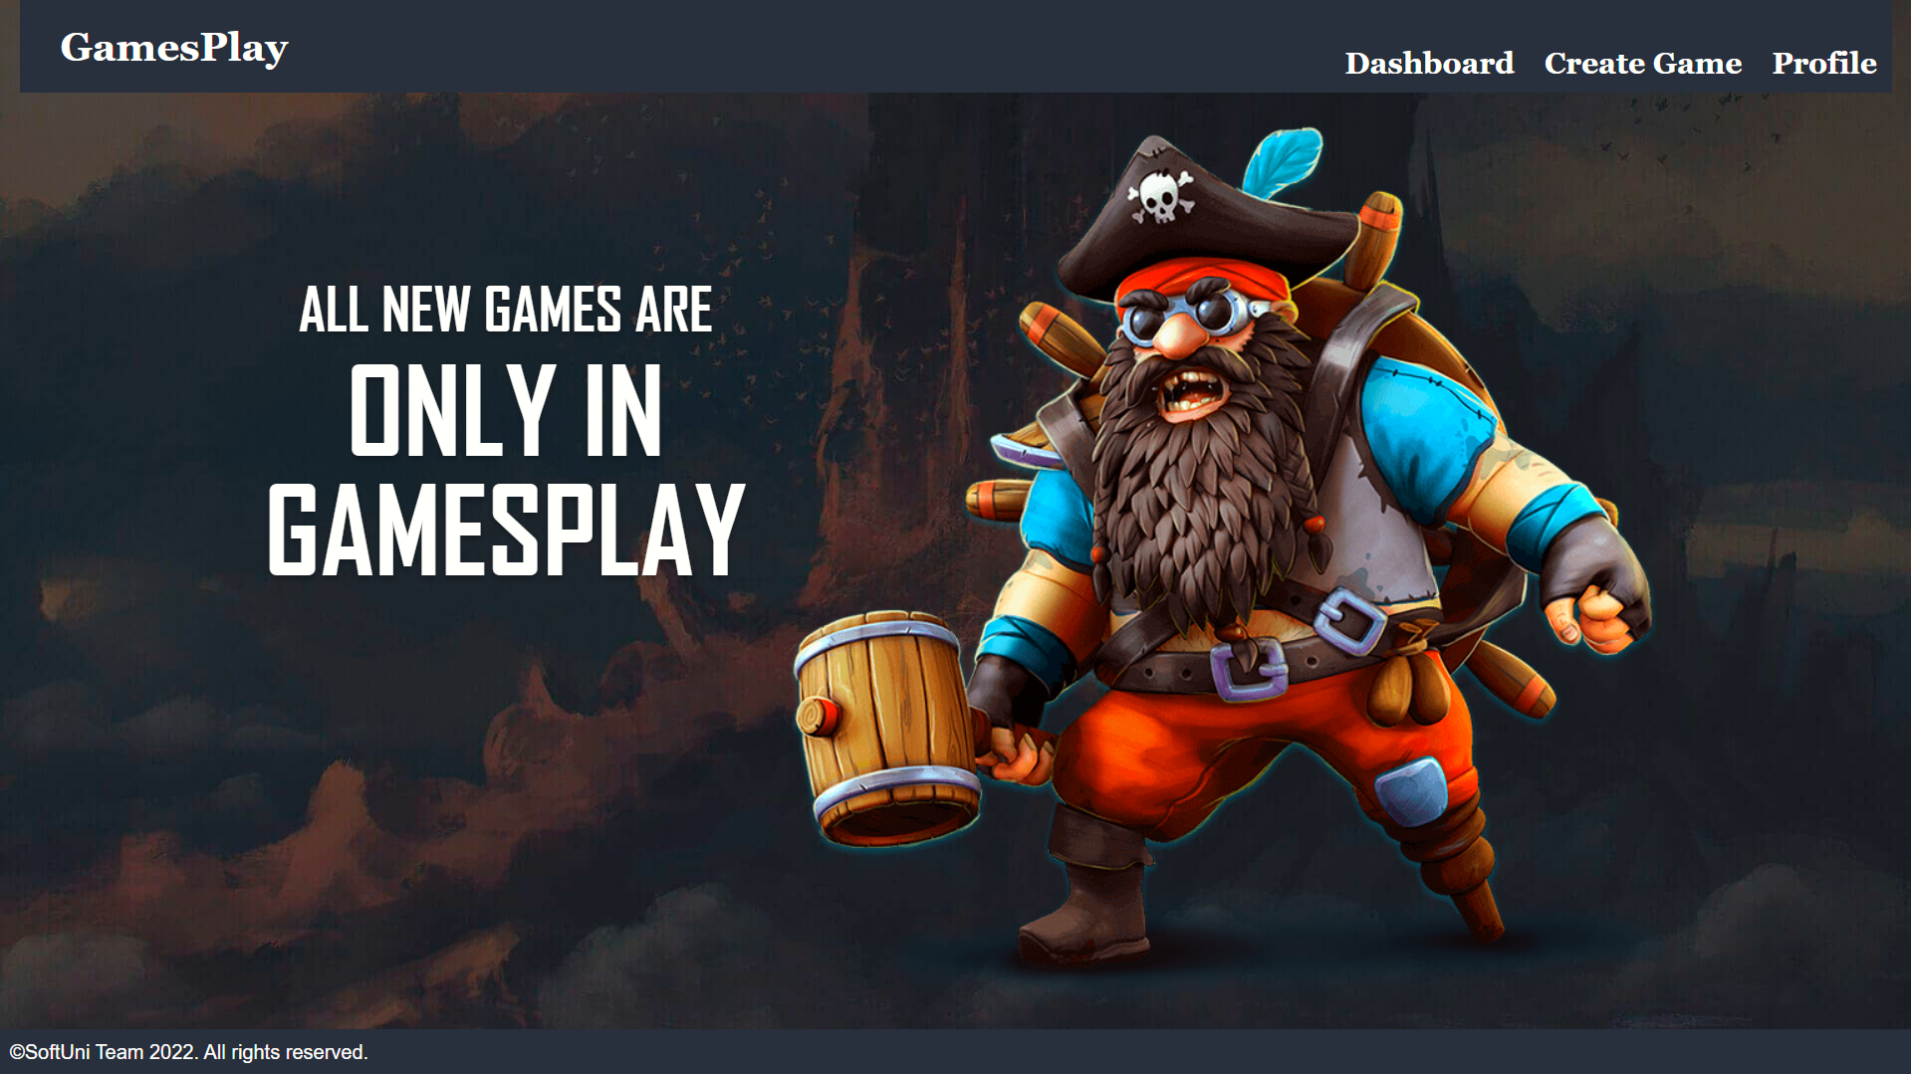

### Create Profile Page - 10p

**Template file**: **"create-profile.html"**

The page consists of:

* A **navigation bar** with:
  + **"GamesPlay"** link, which leads to the **home** page.
  + **"Create Profile"** link, which leads to **create profile** page.
* A **profile** **creation form** consisting of:
  + An **"Email:"** field
  + An **"Age:"** field
  + A **"Password:"** field. In the form, the **characters must be hidden.**
* A button **"Create Profile"**
  + When you **click** on it, **if** the profile is **successfully created**, you should be redirected to the **home page**.
  + Otherwise, the form should show the **appropriate validation errors in the form**.

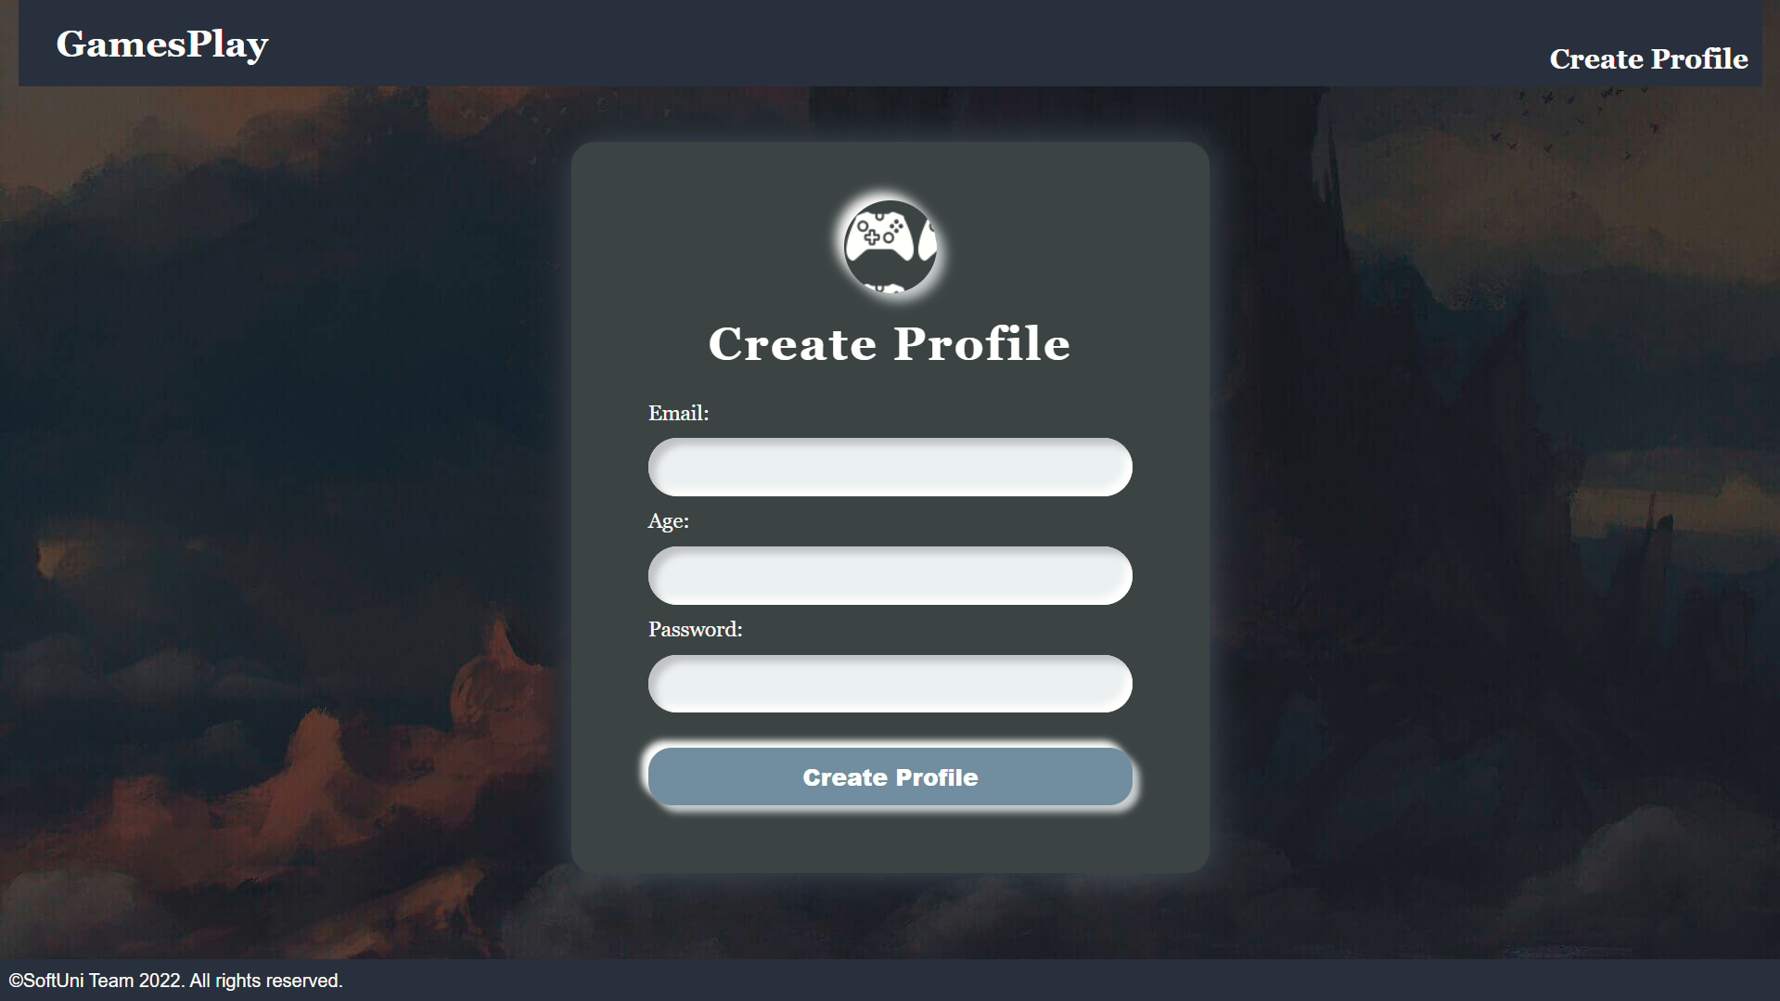

### Dashboard Page - 10p

**Template file**: **"dashboard.html"**

The **dashboard page shows all games created by the user.**

If the **user** **has a profile**, but there are **no games created**, the page should have the following:

* A navigation bar, as shown below.
* A paragraph **"No games yet"**

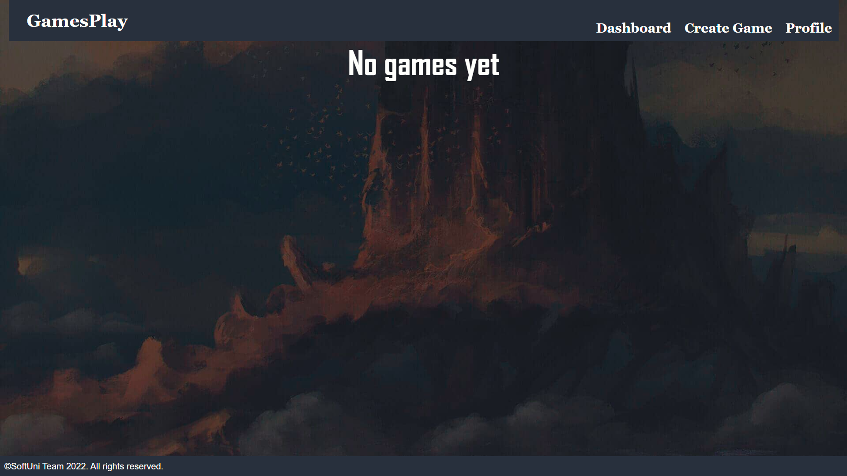

If the **user** **has a profile** and **game/s,** the page should have the following:

* A navigation bar, as shown below.
* A division for each game, showing:
  + The game's **image**
  + The game's **title**
  + The game's **category**
  + A **button** **"Details"** leading to the **details page** for the selected game

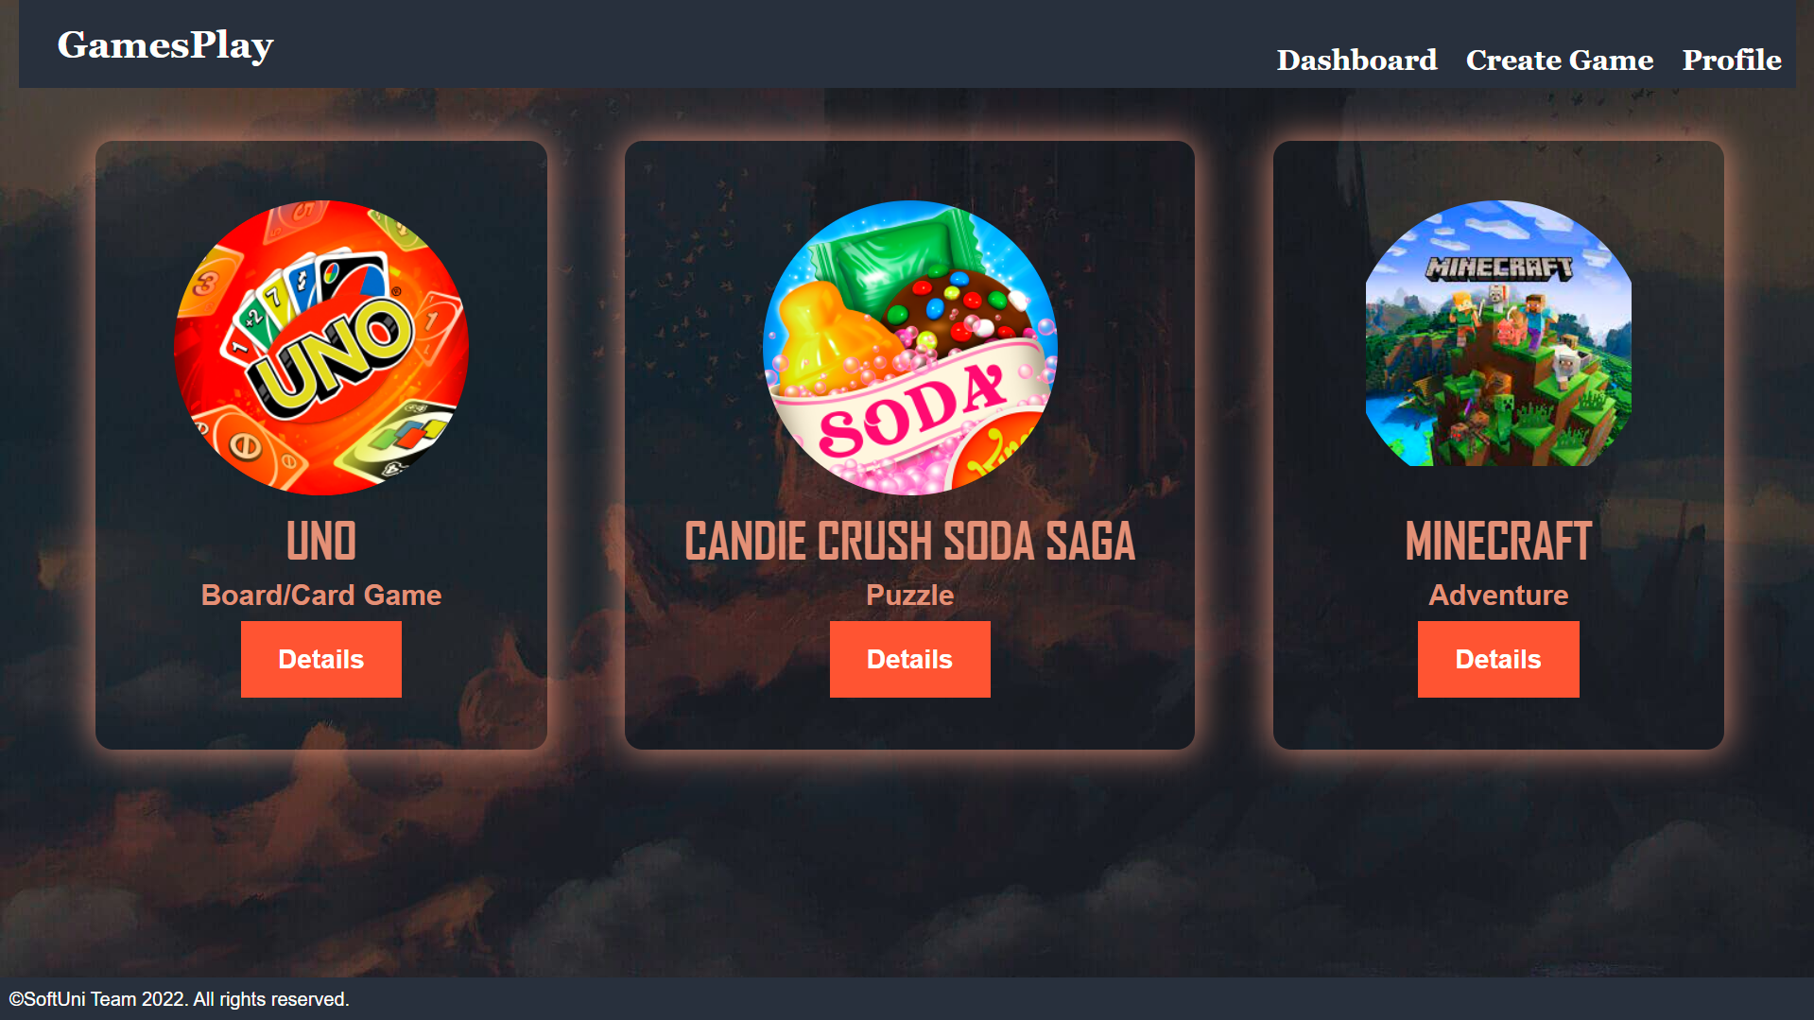

### Create Game Page - 10p

Template file: **"create-game.html"**

The page consists of:

* A **navigation bar,** as shown below.
* A **game** **creation form** consisting of:
  + A **"Title:"** field
  + A **"Category:"** field
  + A **"Rating:"** field
  + A **"Max Level:"** field
  + An **"Image URL:"** field
  + A **"Summary:"** field
* A button **"Create Game"**
  + When you **click** on it, **if** the game is **successfully created**, you should be redirected to the **dashboard page**.
  + Otherwise, the form should show the **appropriate validation errors**.

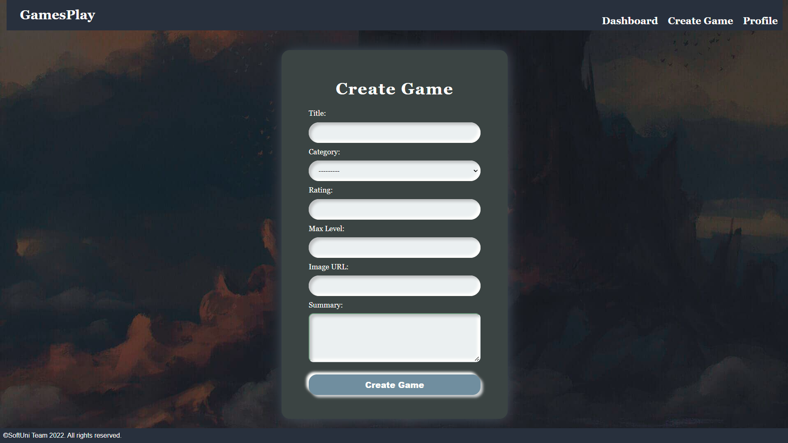

### Game Details Page - 10p

Template file: **"details-game.html"**

This page contains a game's data. It should have the following:

* The **game's** **image**
* The **game's title**
* The **game's rating**
* The **game's** **category**
* The **game's** **max level**, **if there is any entered**; otherwise, ignore the line
* The **game's summary**, **if there is any entered**; otherwise, ignore the line
* An **"Edit"** button that leads to the **edit game page**
* A **"Delete"** button that leads to the **delete game page**

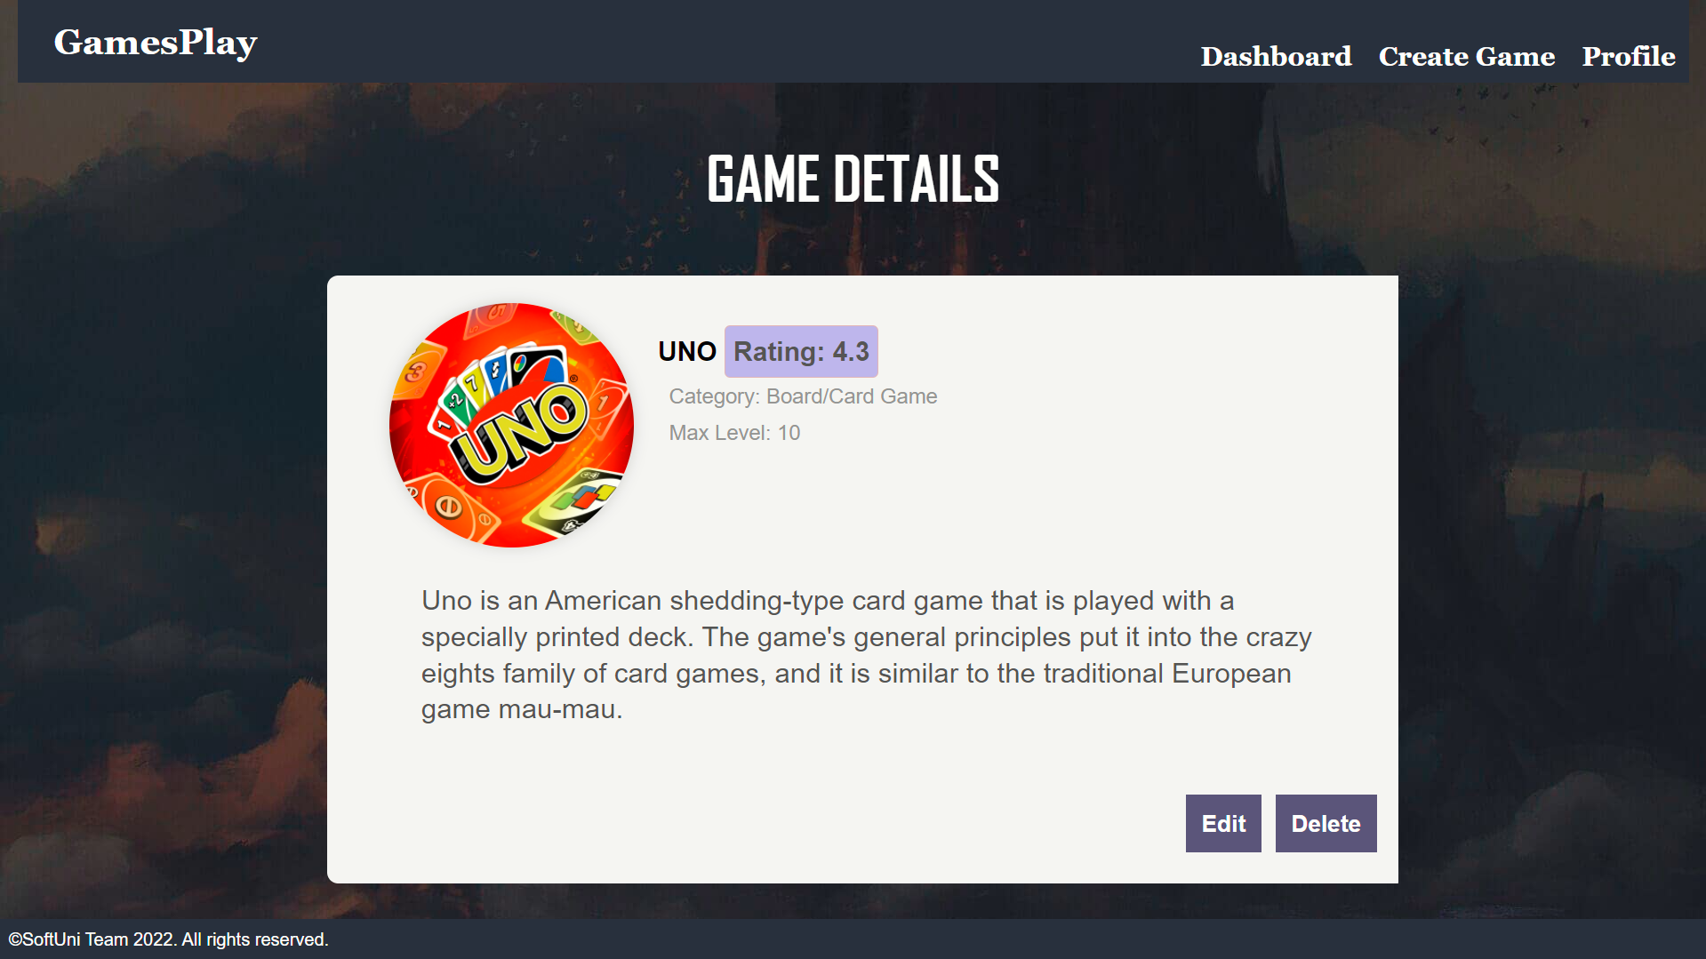

### Edit Game Page - 10p

Template file: **"edit-game.html"**

On the page, the form must be **filled** with the **data** of the **game** we want **to edit.**

When you click on the **"Edit Game"** button:

* **If** the game is **successfully edited**,you should be redirected to the **dashboard page**.
* Otherwise, the form should show the **appropriate validation errors**.

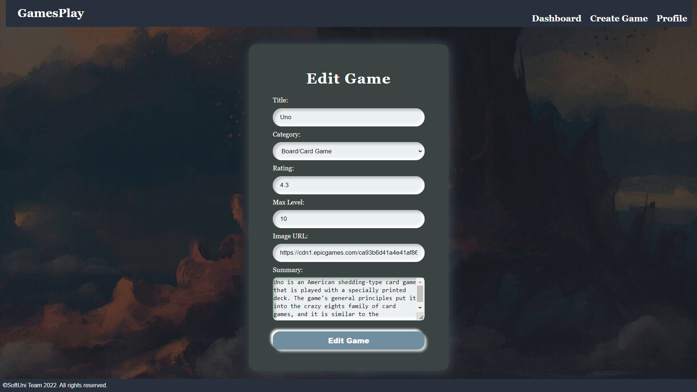

### Delete Game Page - 10p

Template file: **"delete-game.html"**

On the page, the form must be **filled** with the **game's data,** and the **fields** should be **disabled.** When you click on the **"Delete Game"** button, the **game** is **deleted from the database**, and you should be redirected to the **dashboard page**.

The deleted game should be **no longer visible in the app**.

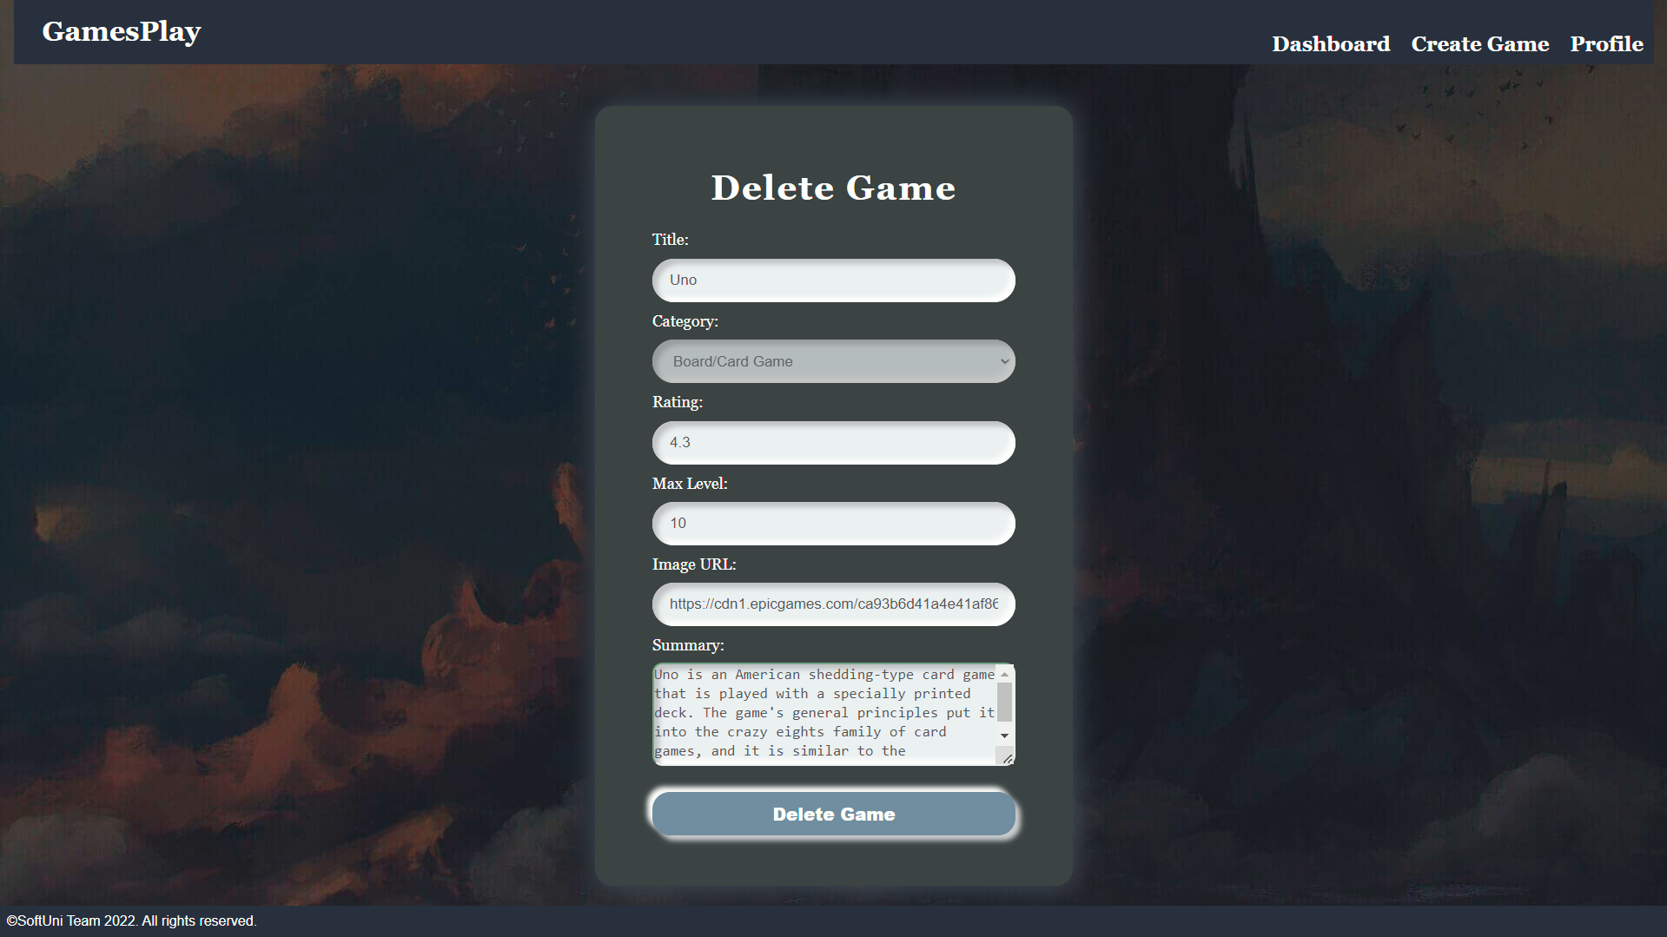

### Profile Details Page - 10p

Template file: **"details-profile.html"**

This page contains the **user's data**. It should have the following:

* A **profile** **picture**. If **no is given**, the page should show a **default profile picture** (in the static/image folder)
* A **name**:
  + If **both names** are entered, show them separated by a **single** **space**
  + If **only** the **first name** or **only** the **last name** is entered, show the **entered name only**
  + Otherwise, ignore the line (do not show anything)
* The **email**
* The **age**
* The **total number of games** existing at the moment in the app
* The **average rating** for all games existing in the app at the moment, if no games show **"0.0"**
* An **"Edit"** button that leads to the **edit profile page**
* A **"Delete"** button that leads to the **delete profile page**

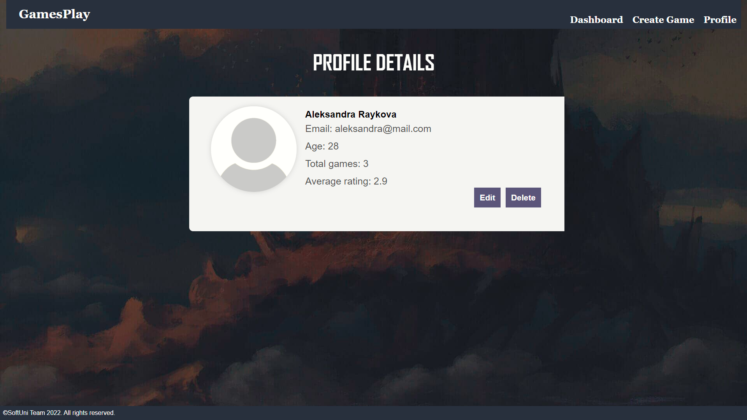

### Edit Profile Page - 10p

Template file: **"edit-profile.html"**

On the page, the form must be **filled** with the **data** of the **profile** we want **to edit. The password could be visible or hidden. The profile** **edition form** has **additional fields as shown below**:

* A **"First Name:"** field
* A **"Last name:"** field
* A **"Profile Picture:"** field

When you click on the **"Edit Profile"** button:

* **If** the profile is **successfully edited**,you should be redirected to the **profile page**.
* Otherwise, the form should show the **appropriate validation errors**.

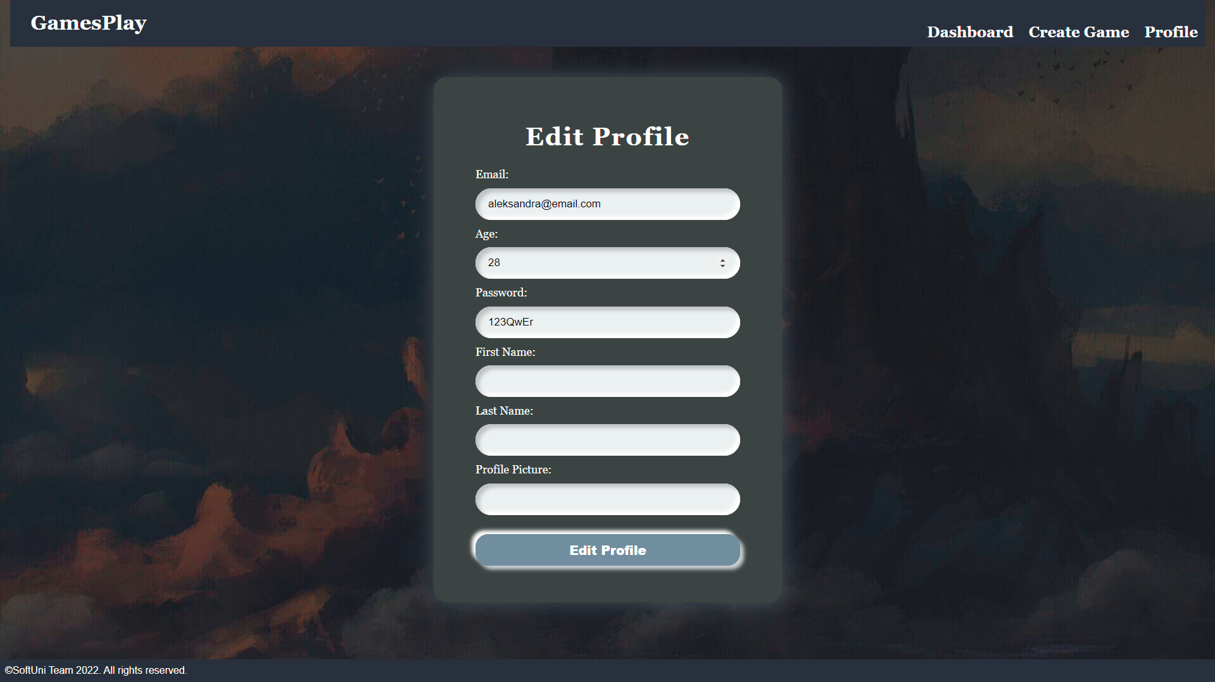

### Delete Profile Page - 10p

Template file: **"delete-profile.html"**

Deleting a profile should delete the profile info and **all games.** After **deletion**, the user should be redirected to the **home page**.

